

**BACHELOR of COMPUTER SCIENCE (SOFTWARE ENGINEERING)**

HOTEL PAYMENT SYSTEM

|  |  |  |
| --- | --- | --- |
| SESSION | : 2018 / 2019 |  |
| COURSE CODE | : CSF 3108 |  |
| COURSE TITLE | : PROGRAMMING |  |
| SUBMITTED DATE | : 13 DECEMBER 2018 |  |
| SUBMITTED TO | : PROF MADYA TS DR MOHD SHUKRI BIN MOHD NOOR |  |
| SUBMITTED BY | : TANG CHOON YEW | S52287 |
|  | : NOUR AZAD ISMADI BIN ANOUR | S52260 |
|  | : SITI FATIMAH AZAHRA BT AZHAR | S52283 |
|  | : SYAZANA FASYIHAH BT ISHAAK | S52279 |

**TABLE OF CONTENT**

|  |  |  |
| --- | --- | --- |
| **NO.** | **CONTENTS** | **PAGES** |
| **1.** | **Introduction** | **3** |
| **2.** | **Executive summary** | **4** |
| **3.** | **Company background** | **5-7** |
| **4.** | **Problem Statement** | **8** |
| **5.** | **Proposed Solution** | **9** |
| **6.** | **Flowchart** | **10** |
| **7.** | **Java Program** | **11-31** |
| **8.** | **Output/ User Manual** | **32-38** |
| **9.** | **Conclusion** | **39** |
| **10.** | **References** | **40** |

**INTRODUCTION**

A hotel is an establishment that accommodates people. The hotel can also be a place where tourist can stay for a limited time. We cannot deny that we are now in much more technologically improvement and especially for business, shifting from manual process to automation and computerize. The cost and quality of hotels are usually indicative of the range and type of services available. Due to the enormous increase in tourism worldwide during the last decades of the 20th century, standards, especially those of smaller establishments, have improved considerably.

Hotel room booking system is a popular method for booking rooms in the hotel. Customer can have booked room on a computer by using internet security to protect their privacy and financial information. Customer can get knowledge about hotel by using several online travel agents to compare price and facilities at different hotel. Hotel room booking is also helpful for making last minute travel arrangements. Hotel may drop the price of the room if some room are still available.

Hotel room booking is to manage all data in your hotel, example booking date, check-in and check-out date, and bills. Hotel rooms are very in need of something fast and reliable to use to make their booking flow fast and organize. Since the advance technology takes place, hotel room booking system was invented. Lastly, these hotel booking system, it provides the hotels room an easy way of doing booking without wasting time and energy.

**EXECUTIVE SUMMARY**

This document provides an analysis and to further develops of our on-going system which is hotel payment system. Method and techniques that we are going to use in developing our system include customer information, booking information and payment details. Admin or employee we have to do also the booking, update the data or the reservation. If customer wishes to do change something and then viewing the records. Upon developing our system, we can add more function and more eaters in our system.

We also hue our limitations in this project, one of this is the payment method that we are going to use in reservation which is only a simulation. We can manage and give a more detailed and specific techniques to let our system more presentable and qualified as a basis for the future purpose. Modules to be consider of this project are as follows. Where for customer booking information is needed because we will base on the information of the booking room hotel that the customer will sign up at booking. Example of booking information that customer need to be enter are the number of room, date check-in and date check-out and also name as information of booking.

Lastly everything on the system process of the customer can check if there is a slot or vacancies of room that particular date view record of customer update. Customer also will receive a receipt as their proof that they have been payment. The system will receive the customer information, booking information and payment details to proceed it.

**COMPANY BACKGROUND**

Langkawi Out hotel is an establish in 2000 with commenced operations in 2005.Centrally located in Kuah, Langkawi Out Hotel puts together the best of business and leisure for travellers seeking a budge-friendly destination hotel in Langkawi, Malaysia. This accommodation sits in a commercial area surrounded by department stores and duty free shops, cinemas, restaurants, banks and more. Most of the tourist from outside and within the country visit Langkawi choose Langkawi Out hotel due to several reasons such as the iconic location, panoramic view of the sea from the hotel.

Highly accessible, guests only need to take 10-minute drive from Kuah Jetty to reach it or a 20- minute drive coming from the Langkawi International Airport. Architecturally, the 3- star hotel is a 7-story beauty that features traditional Malaysian themes. A total of 193 comfortable and spacious rooms and suites await visitors. Each one is air-conditioned and carpeted with single or double beds and a 21-inch television set.

Further, guestroom amenities include a coffee and tea maker, bathroom amenities and free Wi-Fi Internet access. Rooms for the handicapped as well as a non-smoking floor are also available. Additionally, guests can unwind in the swimming in the swimming pool and enjoy satisfying Western and local cuisine at the Hang Tuah Coffee House.

Whether for work or vacation staying in any of the Family room, Deluxe room, Premier room and President room is a guaranteed pleasure. These accommodations come in double and triple set-ups to cater to the needs of travellers. Moreover, the spacious air-conditioned guestrooms are replete with amenities for comfort like free Wi-Fi Internet access, refrigerator, and coffee and tea maker, 21-inch colour TV with Astro channel. A private toilet with bathrooms’ amenities, hair dryer, work desk, IDD phone, alarm clock and baby cot completes the list of conveniences each room offers. There is also conference, seminar and banquet facilities in place. The meeting rooms accommodate 400 people and are equipped with audio-visual and technical equipment. Other useful resources include a tour desk. All these features, which are complemented by an earnest service from our gracious staff are designed to make your stay at our hotel even more expedient.

**VISION**

To be the first choice for guests, colleagues, shareholders and business partners.

**MISSION**

To delight our guests time by creating experiences straight from our heart.

**CONTACT INFORMATION**

|  |  |
| --- | --- |
| NAME | HOTEL LANGKAWI OUT |
| ADDRESS | 65, JALAN PANDAK MAYAH KUAH LANGKAWI, KEDAH |
| CONTACT  NUMBER | 04-5678900 |
| FAX | 04-5678901 |
| WEBSITE  EMAIL | [WWW.LANGKAWIOUT.HOTEL.COM](http://WWW.LANGKAWIOUT.HOTEL.COM)  Langkawi01@out.com |

**BOARD OF DIRECTOR**

**TANG CHOON YEW**

CHIEF EXECUTIVE OFFICER

**SYAZANA FASYIHAH BT ISHAK**

CHIEF FINANCIAL OFFICER

**SITI FATIMAH**

**AZAHRA BT AZHAR**

CHIEF CORPORATE

AND HUMAN RESOURCE OFFICER

**NOUR AZAD ISMADI BIN ANOUR**

CHIEF OPERATING OFFICER

**PROBLEM STATEMENT**

A hotel system manages information about rooms, reservations, customers, and customer billing. A customer can make reservations, change, or cancel reservations through the hotel website. When a customer makes reservations, reception desk needs to check if a room the customer wants to reserve is available. If a room is available, the customer enters his/her information to the system and receives a confirmation number from the web site.

A desk clerk checks in a customer with only a prior reservation, change the checkout date, and check out the customer. A room is assigned to the customer at check-in time and a customer billing record is created at that time. The customer billing record is updated every night at 12. When a customer checks out, the desk clerk prints the bill. A customer can pay by cash, check, or credit card when he/she checks out.

1. Manual system if of time consuming and involved too much the receptionist before the booking list is finally released.

* The receptionist need to record guest/customer reservation manually one by one as the hotel do not have the system. She/he need double checking for the confirmation and it will take too much time to find the data.

1. Lost the data as a result of mishandling in the case of transfers of document (records).

* The receptionist need to distribute the forms to guest/customers to fill their information. Sometimes the form miss place and will cause the data lost.

1. Wrong calculated customers’ room payment.

* The receptionist sometimes cannot have focused on their calculation and cause the wrong calculated. The payment based on customer numbers of days stay at the hotel.

**PROPOSED SOLUTION**

To overcome these problems in our hotel, IT developer is proposed a payment system. This system will automatically calculate the payment, print out the room details and customer information. It can to improve the services such as faster to register for customer, saving the time of waiting in reception counter.

Second proposed is about in our hotel always has lost the data as a result of mishandling in the case of transfers of document records. To avoid this problem we using the payment system will have get accurate of the document records and to avoid the loss data problem occur. Because the system will record all customer information, room type details, and payment information. The system is convenient to our manage the data, save time and less the mistaken.

The last is the hotel is the reception counter always slowly to calculate the bill or calculate wrong cause the customer dislike and customer complain this will affect our hotel reputation, so we must develop the payment system is solve these problem and protect our hotel reputation and star level in the world.

**FLOWCHART**

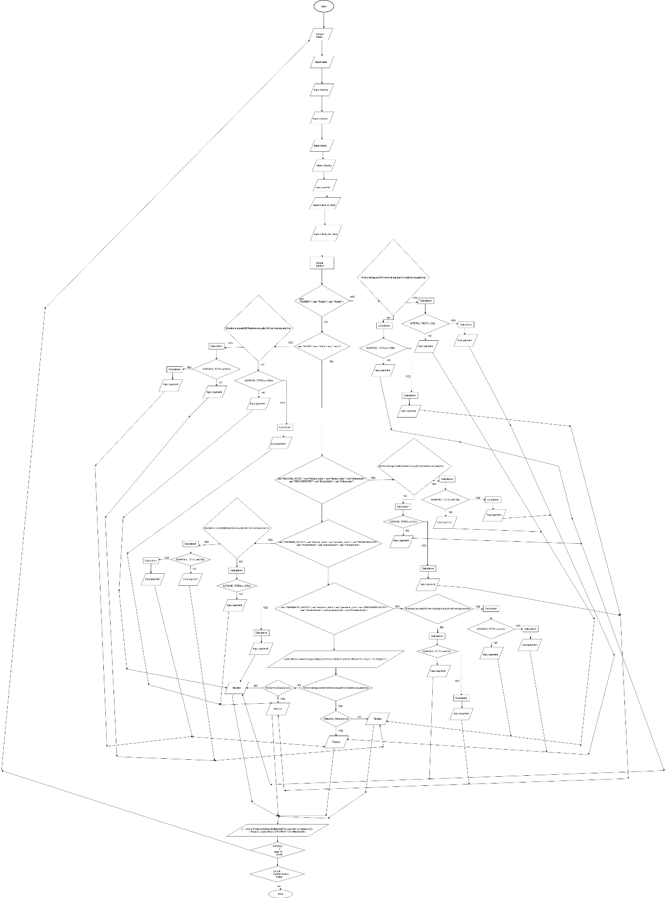

**JAVA PROGRAM**

package hotel2.pkg0;

import javax.swing.JOptionPane;

class DisplayOverloading2

{

String M="Malaysian", m="MALAYSIAN",ma="malaysian",quantity,national,payment,name,Identity,Check_in_Date,Check_out_Date,day,month,years,choice,days,msg,FAMILY="FAMILY",Family="FAMILY",family="FAMILY",SUITE="SUITE",Suite="SUITE",suite="SUITE",DELUXE_SUITE="DELUXE SUITE",Deluxe_Suite="DELUXE SUITE",deluxe_suite="DELUXE SUITE",DELUXESUITE="DELUXE SUITE",deluxesuite="DELUXE SUITE",DeluxeSuite="DELUXE SUITE",Deluxesuite="DELUXE SUITE",PREMIER_SUITE="PREMIER SUITE",Premier_Suite="PREMIER SUITE",premier_suite="PREMIER SUITE",PREMIERSUITE="PREMIER SUITE",PremierSuite="PREMIER SUITE",premiersuite="PREMIER SUITE",Premiersuite="PREMIER SUITE",PRESIDENT_SUITE="PRESIDENT SUITE",President_Suite="PRESIDENT SUITE",president_suite="PRESIDENT SUITE",PRESIDENTSUITE="PRESIDENT SUITE",PresidentSuite="PRESIDENT SUITE",presidentsuite="PRESIDENT SUITE",Presidentsuite="PRESIDENT SUITE";

Double Quantity,Total,Second_Disccount,S_D=0.05,D,RENT,SERVICE_CHARGE,TOTAL_RENT,PAYMENT_FROM_CUSTOMER,Balance,F=350,S=600,DS=750,PS=900,P_S=1500,Service_charge=0.10,Disccount=0.05,Dis,GRAND_TOTAL;

public void menu(int menu)

{

String[][] Menu = { { "Room Type Price(RM)Per Night"}, { "FAMILY 350"}, { "SUITE 600"}, { "DELUXE SUITE 750"} , { "PREMIER SUITE 900"}, { "PRISIDENT SUITE 1500"} };

JOptionPane.showMessageDialog(null,Menu);

}

public void info(int info)

{

name = JOptionPane.showInputDialog(null,"Please Enter Your Name: ","Customer Name",JOptionPane.INFORMATION_MESSAGE);

Identity = JOptionPane.showInputDialog(null,"Please Enter Your Identity Card Number with format (96041508xxxx) or Passport Number: ","Identity Card Number or Passport Number",JOptionPane.WARNING_MESSAGE);

national = JOptionPane.showInputDialog(null,"Please Enter Your National:(e.g Malaysian) ","National",JOptionPane.INFORMATION_MESSAGE);

choice = JOptionPane.showInputDialog(null,"Please Enter Your Choice:(e.g premiersuite)","Room Choice",JOptionPane.INFORMATION_MESSAGE);

days = JOptionPane.showInputDialog(null,"Please Enter How Long To Staying: ","Staying",JOptionPane.INFORMATION_MESSAGE);

quantity = JOptionPane.showInputDialog(null,"Please Enter Quantity of Room: ","Quantity of Room",JOptionPane.INFORMATION_MESSAGE);

Check_in_Date=JOptionPane.showInputDialog(null,"Please Enter Check in Date with format in DD-MM-YY or DD/MM/YYYY.: ","Check in Date",JOptionPane.INFORMATION_MESSAGE);

Check_out_Date=JOptionPane.showInputDialog(null,"Please Enter Check out Date with format in DD-MM-YY or DD/MM/YYYY.: ","Check out Date",JOptionPane.INFORMATION_MESSAGE);

D = Double.parseDouble(days);

Quantity=Double.parseDouble(quantity);

}

public void choose(int choose)

{

switch(choice)

{

case "FAMILY": case "Family": case "family":

if(national.equals(M)||national.equals(m)||national.equals(ma))

{

RENT= F*D*Quantity;

SERVICE_CHARGE=RENT*Service_charge;

TOTAL_RENT=RENT+SERVICE_CHARGE;

Dis=Disccount*TOTAL_RENT;

GRAND_TOTAL=TOTAL_RENT-Dis;

if(GRAND_TOTAL>=1050)

{

Second_Disccount=GRAND_TOTAL*S_D;

Total=GRAND_TOTAL-Second_Disccount;

payment = JOptionPane.showInputDialog(null,"GRAND TOTAL RM"+Total,"PAYMENT FROM CUSTOMER",JOptionPane.INFORMATION_MESSAGE);

PAYMENT_FROM_CUSTOMER = Double.parseDouble(payment);

Balance=PAYMENT_FROM_CUSTOMER-Total;

}

else

{

payment = JOptionPane.showInputDialog(null,"GRAND TOTAL RM"+GRAND_TOTAL,"PAYMENT FROM CUSTOMER",JOptionPane.INFORMATION_MESSAGE);

PAYMENT_FROM_CUSTOMER = Double.parseDouble(payment);

Balance=PAYMENT_FROM_CUSTOMER- GRAND_TOTAL;

}

}

else

{

RENT= F*D*Quantity;

SERVICE_CHARGE=RENT*Service_charge;

TOTAL_RENT=RENT+SERVICE_CHARGE;

if( TOTAL_RENT>=1050)

{

Second_Disccount=TOTAL_RENT*S_D;

Total=TOTAL_RENT-Second_Disccount;

payment = JOptionPane.showInputDialog(null,"GRAND TOTAL RM"+Total,"PAYMENT FROM CUSTOMER",JOptionPane.INFORMATION_MESSAGE);

PAYMENT_FROM_CUSTOMER = Double.parseDouble(payment);

Balance=PAYMENT_FROM_CUSTOMER-Total;

}

else

{

payment = JOptionPane.showInputDialog(null,"GRAND TOTAL RM"+TOTAL_RENT,"PAYMENT FROM CUSTOMER",JOptionPane.INFORMATION_MESSAGE);

PAYMENT_FROM_CUSTOMER = Double.parseDouble(payment);

Balance=PAYMENT_FROM_CUSTOMER-TOTAL_RENT;

}

}

break;

case "SUITE": case "Suite": case "suite":

if(national.equals(M)||national.equals(m)||national.equals(ma))

{

RENT= S*D*Quantity;

SERVICE_CHARGE=RENT*Service_charge;

TOTAL_RENT=RENT+SERVICE_CHARGE;

Dis=Disccount*TOTAL_RENT;

GRAND_TOTAL=TOTAL_RENT-Dis;

if(GRAND_TOTAL>=1800)

{

Second_Disccount=GRAND_TOTAL*S_D;

Total=GRAND_TOTAL-Second_Disccount;

payment = JOptionPane.showInputDialog(null,"GRAND TOTAL RM"+Total,"PAYMENT FROM CUSTOMER",JOptionPane.INFORMATION_MESSAGE);

PAYMENT_FROM_CUSTOMER = Double.parseDouble(payment);

Balance=PAYMENT_FROM_CUSTOMER-Total;

}

else

{

payment = JOptionPane.showInputDialog(null,"GRAND TOTAL RM"+GRAND_TOTAL,"PAYMENT FROM CUSTOMER",JOptionPane.INFORMATION_MESSAGE);

PAYMENT_FROM_CUSTOMER = Double.parseDouble(payment);

Balance=PAYMENT_FROM_CUSTOMER- GRAND_TOTAL;

}

}

else

{

RENT= S*D*Quantity;

SERVICE_CHARGE=RENT*Service_charge;

TOTAL_RENT=RENT+SERVICE_CHARGE;

if( TOTAL_RENT>=1800)

{

Second_Disccount=TOTAL_RENT*S_D;

Total=TOTAL_RENT-Second_Disccount;

payment = JOptionPane.showInputDialog(null,"GRAND TOTAL RM"+Total,"PAYMENT FROM CUSTOMER",JOptionPane.INFORMATION_MESSAGE);

PAYMENT_FROM_CUSTOMER = Double.parseDouble(payment);

Balance=PAYMENT_FROM_CUSTOMER-Total;

}

else

{

payment = JOptionPane.showInputDialog(null,"GRAND TOTAL RM"+TOTAL_RENT,"PAYMENT FROM CUSTOMER",JOptionPane.INFORMATION_MESSAGE);

PAYMENT_FROM_CUSTOMER = Double.parseDouble(payment);

Balance=PAYMENT_FROM_CUSTOMER-TOTAL_RENT;

}

}

break;

case"DELUXE_SUITE": case"Deluxe_Suite": case"deluxe_suite": case"deluxesuite": case"DELUXESUITE": case"DeluxeSuite": case"Deluxesuite":

if(national.equals(M)||national.equals(m)||national.equals(ma))

{

RENT= DS*D*Quantity;

SERVICE_CHARGE=RENT*Service_charge;

TOTAL_RENT=RENT+SERVICE_CHARGE;

Dis=Disccount*TOTAL_RENT;

GRAND_TOTAL=TOTAL_RENT-Dis;

if(GRAND_TOTAL>=2150)

{

Second_Disccount=GRAND_TOTAL*S_D;

Total=GRAND_TOTAL-Second_Disccount;

payment = JOptionPane.showInputDialog(null,"GRAND TOTAL RM"+Total,"PAYMENT FROM CUSTOMER",JOptionPane.INFORMATION_MESSAGE);

PAYMENT_FROM_CUSTOMER = Double.parseDouble(payment);

Balance=PAYMENT_FROM_CUSTOMER-Total;

}

else

{

payment = JOptionPane.showInputDialog(null,"GRAND TOTAL RM"+GRAND_TOTAL,"PAYMENT FROM CUSTOMER",JOptionPane.INFORMATION_MESSAGE);

PAYMENT_FROM_CUSTOMER = Double.parseDouble(payment);

Balance=PAYMENT_FROM_CUSTOMER- GRAND_TOTAL;

}

}

else

{

RENT= DS*D*Quantity;

SERVICE_CHARGE=RENT*Service_charge;

TOTAL_RENT=RENT+SERVICE_CHARGE;

if( TOTAL_RENT>=2150)

{

Second_Disccount=TOTAL_RENT*S_D;

Total=TOTAL_RENT-Second_Disccount;

payment = JOptionPane.showInputDialog(null,"GRAND TOTAL RM"+Total,"PAYMENT FROM CUSTOMER",JOptionPane.INFORMATION_MESSAGE);

PAYMENT_FROM_CUSTOMER = Double.parseDouble(payment);

Balance=PAYMENT_FROM_CUSTOMER-Total;

}

else

{

payment = JOptionPane.showInputDialog(null,"GRAND TOTAL RM"+TOTAL_RENT,"PAYMENT FROM CUSTOMER",JOptionPane.INFORMATION_MESSAGE);

PAYMENT_FROM_CUSTOMER = Double.parseDouble(payment);

Balance=PAYMENT_FROM_CUSTOMER-TOTAL_RENT;

}

}

break;

case"PREMIER_SUITE": case"Premier_Suite": case"premier_suite": case"PREMIERSUITE": case"PremierSuite": case"premiersuite": case"Premiersuite":

if(national.equals(M)||national.equals(m)||national.equals(ma))

{

RENT= PS*D*Quantity;

SERVICE_CHARGE=RENT*Service_charge;

TOTAL_RENT=RENT+SERVICE_CHARGE;

Dis=Disccount*TOTAL_RENT;

GRAND_TOTAL=TOTAL_RENT-Dis;

if(GRAND_TOTAL>=2700)

{

Second_Disccount=GRAND_TOTAL*S_D;

Total=GRAND_TOTAL-Second_Disccount;

payment = JOptionPane.showInputDialog(null,"GRAND TOTAL RM"+Total,"PAYMENT FROM CUSTOMER",JOptionPane.INFORMATION_MESSAGE);

PAYMENT_FROM_CUSTOMER = Double.parseDouble(payment);

Balance=PAYMENT_FROM_CUSTOMER-Total;

}

else

{

payment = JOptionPane.showInputDialog(null,"GRAND TOTAL RM"+GRAND_TOTAL,"PAYMENT FROM CUSTOMER",JOptionPane.INFORMATION_MESSAGE);

PAYMENT_FROM_CUSTOMER = Double.parseDouble(payment);

Balance=PAYMENT_FROM_CUSTOMER- GRAND_TOTAL;

}

}

else

{

RENT= PS*D*Quantity;

SERVICE_CHARGE=RENT*Service_charge;

TOTAL_RENT=RENT+SERVICE_CHARGE;

if( TOTAL_RENT>=2700)

{

Second_Disccount=TOTAL_RENT*S_D;

Total=TOTAL_RENT-Second_Disccount;

payment = JOptionPane.showInputDialog(null,"GRAND TOTAL RM"+Total,"PAYMENT FROM CUSTOMER",JOptionPane.INFORMATION_MESSAGE);

PAYMENT_FROM_CUSTOMER = Double.parseDouble(payment);

Balance=PAYMENT_FROM_CUSTOMER-Total;

}

else

{

payment = JOptionPane.showInputDialog(null,"GRAND TOTAL RM"+TOTAL_RENT,"PAYMENT FROM CUSTOMER",JOptionPane.INFORMATION_MESSAGE);

PAYMENT_FROM_CUSTOMER = Double.parseDouble(payment);

Balance=PAYMENT_FROM_CUSTOMER-TOTAL_RENT;

}

}

break;

case"PRESIDENT_SUITE": case"President_Suite": case"president_suite": case"PRESIDENTSUITE": case"PresidentSuite": case"presidentsuite": case"Presidentsuite":

if(national.equals(M)||national.equals(m)||national.equals(ma))

{

RENT= P_S*D*Quantity;

SERVICE_CHARGE=RENT*Service_charge;

TOTAL_RENT=RENT+SERVICE_CHARGE;

Dis=Disccount*TOTAL_RENT;

GRAND_TOTAL=TOTAL_RENT-Dis;

if(GRAND_TOTAL>=4500)

{

Second_Disccount=GRAND_TOTAL*S_D;

Total=GRAND_TOTAL-Second_Disccount;

payment = JOptionPane.showInputDialog(null,"GRAND TOTAL RM"+Total,"PAYMENT FROM CUSTOMER",JOptionPane.INFORMATION_MESSAGE);

PAYMENT_FROM_CUSTOMER = Double.parseDouble(payment);

Balance=PAYMENT_FROM_CUSTOMER-Total;

}

else

{

payment = JOptionPane.showInputDialog(null,"GRAND TOTAL RM"+GRAND_TOTAL,"PAYMENT FROM CUSTOMER",JOptionPane.INFORMATION_MESSAGE);

PAYMENT_FROM_CUSTOMER = Double.parseDouble(payment);

Balance=PAYMENT_FROM_CUSTOMER- GRAND_TOTAL;

}

}

else

{

RENT= P_S*D*Quantity;

SERVICE_CHARGE=RENT*Service_charge;

TOTAL_RENT=RENT+SERVICE_CHARGE;

if( TOTAL_RENT>=4500)

{

Second_Disccount=TOTAL_RENT*S_D;

Total=TOTAL_RENT-Second_Disccount;

payment = JOptionPane.showInputDialog(null,"GRAND TOTAL RM"+Total,"PAYMENT FROM CUSTOMER",JOptionPane.INFORMATION_MESSAGE);

PAYMENT_FROM_CUSTOMER = Double.parseDouble(payment);

Balance=PAYMENT_FROM_CUSTOMER-Total;

}

else

{

payment = JOptionPane.showInputDialog(null,"GRAND TOTAL RM"+TOTAL_RENT,"PAYMENT FROM CUSTOMER",JOptionPane.INFORMATION_MESSAGE);

PAYMENT_FROM_CUSTOMER = Double.parseDouble(payment);

Balance=PAYMENT_FROM_CUSTOMER-TOTAL_RENT;

}

}

break;

default:

JOptionPane.showMessageDialog(null,"Invalid Enter Customer Please Run Again The Program");

break;

}

}

public void output(int output)

{

if(national.equals(M)||national.equals(m)||national.equals(ma))

{

if(Second_Disccount>0)

{

JOptionPane.showMessageDialog(null,"*****************************************************"+"\n"+

"HOTEL LANGKAWI OUT"+"\n"+

"65, JALAN PANDAK MAYAH, KUAH LANGKAWI"+"\n"+

"TEL: 04-5678900 FAX: 04-5678901"+"\n"+

"*****************************************************"+"\n"+

"\n"+

"CUSTOMER NAME: "+name+"\n"+

"Identity Card Number or Passport Number: "+Identity+"\n"+

"National: "+national+"\n"+

"\n"+

"***********ROOM TYPE************"+"\n"+

"\n"+

"Your Room Type: "+choice+"\n"+

"Staying For (Days): "+days+"\n"+

"Quantity of Room: "+Quantity+"\n"+

"Check in Date:" +Check_in_Date+"\n"+

"Check out Date:" +Check_out_Date+"\n"+

"\n"+

"**************PAYMENT DETAILS****************"+"\n"+

"\n"+

"Rent:RM "+RENT+"\n"+

"SERVICE CHARGE:RM "+SERVICE_CHARGE+"\n"+

"TOTAL RENT:RM "+TOTAL_RENT+"\n"+

"Discount (5%):RM "+Dis+"\n"+

"GRAND TOTAL:RM"+GRAND_TOTAL+"\n"+

"Promotion Discount (5%):RM"+Second_Disccount+"\n"+

"Total:RM"+Total+"\n"+

"YOUR PAYMENT FROM CUSTOMER:RM"+PAYMENT_FROM_CUSTOMER+"\n"+

"Balance:RM"+String.format("%.2f", (Balance))+"\n"+

"\n"+

"**************THANK YOU.PLEASE COME AGAIN**************","RECEIPT", JOptionPane.INFORMATION_MESSAGE);

}

else

{

JOptionPane.showMessageDialog(null,"*******************************************************"+"\n"+

"HOTEL LANGKAWI OUT"+"\n"+

"65, JALAN PANDAK MAYAH, KUAH LANGKAWI"+"\n"+

"TEL: 04-5678900 FAX: 04-5678901"+"\n"+

"******************************************************"+"\n"+

"\n"+

"CUSTOMER NAME: "+name+"\n"+

"Identity Card Number or Passport Number: "+Identity+"\n"+

"National: "+national+"\n"+

"\n"+

"***********ROOM TYPE************"+"\n"+

"\n"+

"Your Room Type: "+choice+"\n"+

"Staying For (Days): "+days+"\n"+

"Quantity of Room: "+Quantity+"\n"+

"Check in Date:" +Check_in_Date+"\n"+

"Check out Date:" +Check_out_Date+"\n"+

"\n"+

"**************PAYMENT DETAILS****************"+"\n"+

"\n"+

"Rent:RM "+RENT+"\n"+

"SERVICE CHARGE:RM "+SERVICE_CHARGE+"\n"+

"TOTAL RENT:RM "+TOTAL_RENT+"\n"+

"Discount (5%):RM "+Dis+"\n"+

"TOTAL:RM"+GRAND_TOTAL+"\n"+

"YOUR PAYMENT FROM CUSTOMER:RM"+PAYMENT_FROM_CUSTOMER+"\n"+

"Balance:RM"+String.format("%.2f", (Balance))+"\n"+

"\n"+

"**************THANK YOU.PLEASE COME AGAIN**************","RECEIPT", JOptionPane.INFORMATION_MESSAGE);

}

}

else

{

if(Second_Disccount>0)

{

JOptionPane.showMessageDialog(null,"********************************************************"+"\n"+

"HOTEL LANGKAWI OUT"+"\n"+

"65, JALAN PANDAK MAYAH, KUAH LANGKAWI"+"\n"+

"TEL: 04-5678900 FAX: 04-5678901"+"\n"+

"*******************************************************"+"\n"+

"\n"+

"CUSTOMER NAME: "+name+"\n"+

"Identity Card Number or Passport Number: "+Identity+"\n"+

"National: "+national+"\n"+

"\n"+

"***********ROOM TYPE************"+"\n"+

"\n"+

"Your Room Type: "+choice+"\n"+

"Staying For (Days): "+days+"\n"+

"Quantity of Room: "+Quantity+"\n"+

"Check in Date:" +Check_in_Date+"\n"+

"Check out Date:" +Check_out_Date+"\n"+

"\n"+

"**************PAYMENT DETAILS****************"+"\n"+

"\n"+

"Rent:RM "+RENT+"\n"+

"SERVICE CHARGE:RM "+SERVICE_CHARGE+"\n"+

"TOTAL RENT:RM "+TOTAL_RENT+"\n"+

"Promotion Discount (5%):RM"+Second_Disccount+"\n"+

"Total:RM"+Total+"\n"+

"YOUR PAYMENT FROM CUSTOMER:RM"+PAYMENT_FROM_CUSTOMER+"\n"+

"Balance:RM"+String.format("%.2f", (Balance))+"\n"+

"\n"+

"**************THANK YOU.PLEASE COME AGAIN**************","RECEIPT", JOptionPane.INFORMATION_MESSAGE);

}

else

{

JOptionPane.showMessageDialog(null,"*******************************************************"+"\n"+

"HOTEL LANGKAWI OUT"+"\n"+

"65, JALAN PANDAK MAYAH, KUAH LANGKAWI"+"\n"+

"TEL: 04-5678900 FAX: 04-5678901"+"\n"+

"*****************************************************"+"\n"+

"\n"+

"CUSTOMER NAME: "+name+"\n"+

"Identity Card Number or Passport Number: "+Identity+"\n"+

"National: "+national+"\n"+

"\n"+

"***********ROOM TYPE************"+"\n"+

"\n"+

"Your Room Type: "+choice+"\n"+

"Staying For (Days): "+days+"\n"+

"Quantity of Room: "+Quantity+"\n"+

"Check in Date:" +Check_in_Date+"\n"+

"Check out Date:" +Check_out_Date+"\n"+

"\n"+

"**************PAYMENT DETAILS****************"+"\n"+

"\n"+

"Rent:RM "+RENT+"\n"+

"SERVICE CHARGE:RM "+SERVICE_CHARGE+"\n"+

"TOTAL:RM "+TOTAL_RENT+"\n"+

"YOUR PAYMENT FROM CUSTOMER:RM"+PAYMENT_FROM_CUSTOMER+"\n"+

"Balance:RM"+String.format("%.2f", (Balance))+"\n"+

"\n"+

"**************THANK YOU.PLEASE COME AGAIN**************","RECEIPT", JOptionPane.INFORMATION_MESSAGE);

}

}

}

}

public class Hotel20

{

public static void main(String[] args)

{

boolean again =true;

while(again)

{

DisplayOverloading2 obj = new DisplayOverloading2();

obj.menu(1);

obj.info(2);

obj.choose(3);

obj.output(4);

String y="y",n="n";

y = JOptionPane.showInputDialog(null,"Do you want to repeat (y/n): ","Repeat",JOptionPane.INFORMATION_MESSAGE);

switch(y)

{

case "y":

break;

default:

System.exit(0);

break;

}

}

}

}

**OUTPUT/USER MANUAL**

1. Display menu

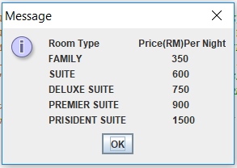

1. Input customer name

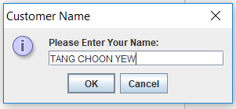

1. Input Identity card number or Passport number

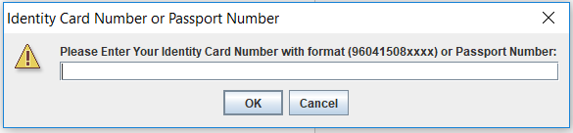

1. Input National

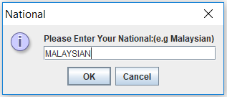

1. Customer choose the room type

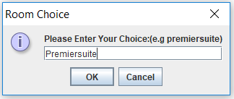

1. Input how long to stay

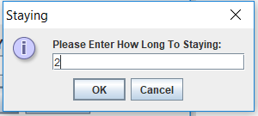

1. Input Quantity of room

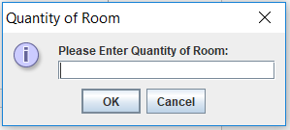

1. Input Check in Date

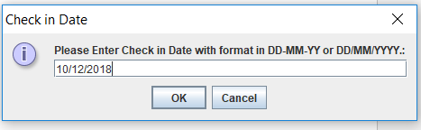

1. Input Check out Date

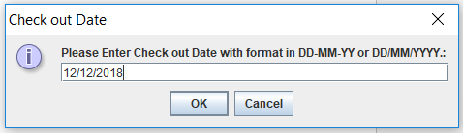

1. Input payment

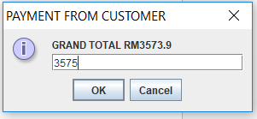

1. Asking the user need to repeat the system?

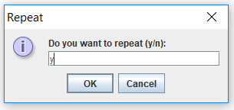

1. When user input y system run again to menu .

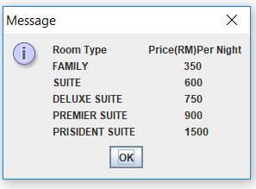

1. Else user input n

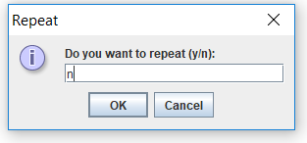

1. The system will be exit.

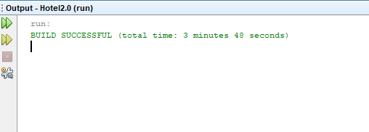

1. Receipt

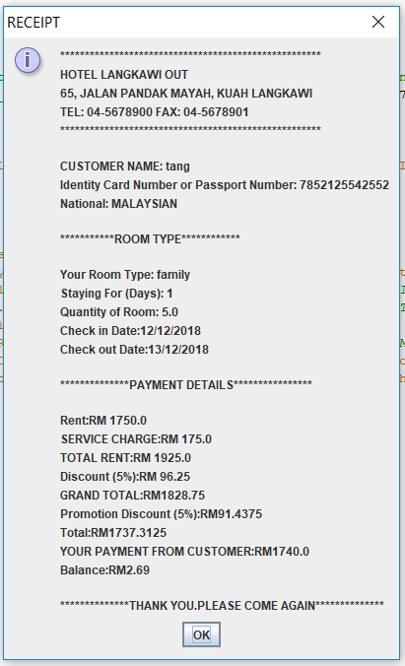

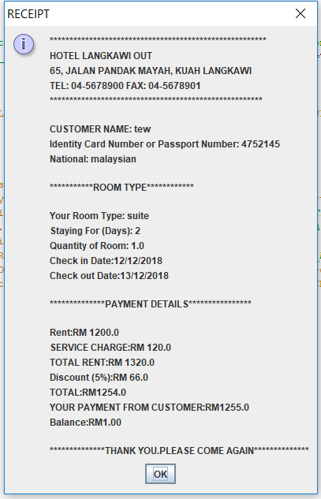

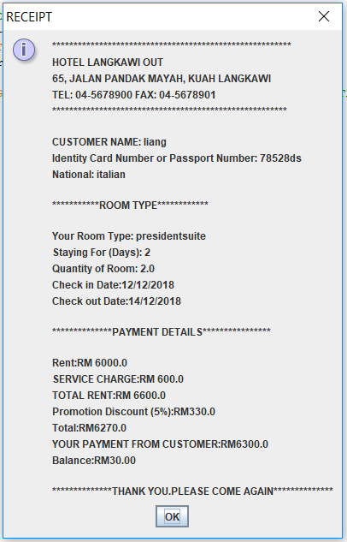

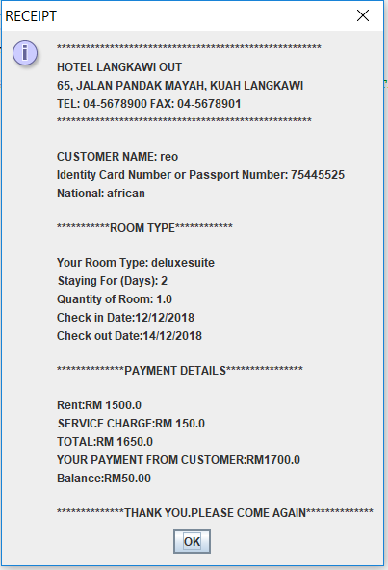

**CONCLUSION**

As conclusion, hotel payment system are really needed. It is because it’s really help for the customer to do payment in shorter time at reception counter. So it is easier way of doing payment without wasting time and energy. This system can handle almost the entire task required in to the management of hotel being one of the key to raise the organization prestige and status as it saves processing time and help to provide better management system. Using this software one can make their managerial aspect of hotel strong and fast.

Integrating our payment system with a more modern online based reservation system and better software information processed will become precise, reliable accessible and sure with the use internet. Lastly with this system reservation customer will have the convenience of reserving a room or booking an event whenever they want at the comfort of their own home.

**REFERENCES**

**WEBSITE**

1. <https://freebooksummary.com/executive-summary-of-hotel-reservation-system-essay>
2. <https://www.littlehotelier.com/r/small-hotel-technology/booking-systems/hotel-reservation-systems-work/>
3. <https://www.tutorialspoint.com/java/java_arrays.htm>
4. <https://www.geeksforgeeks.org/overloading-in-java/>

**BOOK**

1. Farrell, J. (2017). Java Programming. Eight Edition. USA: Cengage Learning. Chapter 5 making decision page 251-253 and 274-279.